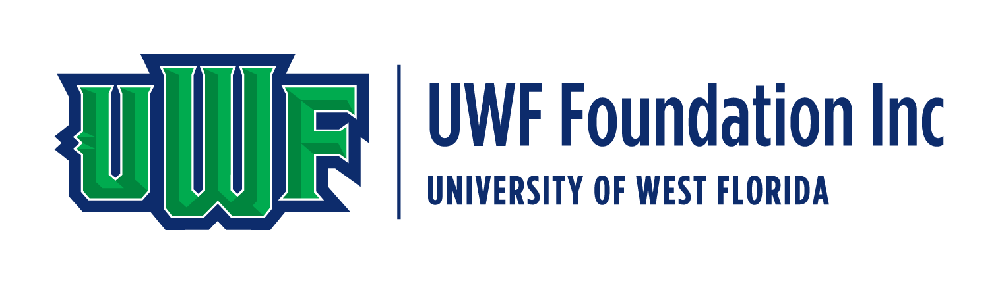
PUBLIC NOTICE

Two or more members of the University of West Florida Foundation, Inc. Board of Directors may attend the following football games and/or President’s tailgates at PenAir Field on the UWF Pensacola campus.
No business of the Foundation Board of Directors will be conducted at any of these events.

August 27, 2026 – Southern Illinois @ 6 pm (White Out)
September 19, 2026 – Austin Peay @ 6 pm (Family Weekend)
October 10, 2026 – Northeastern State @ 4 pm (Cancer Awareness)
October 17, 2026 – West Alabama @ 4 pm (Homecoming)
November 14, 2026 – Tarleton State @ 2 pm (Salute to Service/Senior Day)

Contact the UWF Foundation office at 850.474.3306 for more information.

