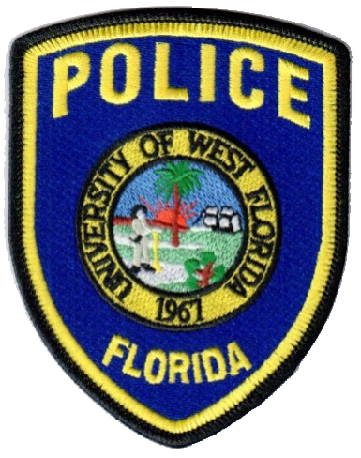
October 5, 2022

The University of West Florida Police Department
11000 University Parkway
Pensacola, FL 32514
(850) 474-2415

Accreditation Team invites public comments about the University of West Florida Police Department
A team of assessors from the Commission for Florida Law Enforcement Accreditation will be at the University of West Florida Police Department on Nov. 15-17, 2022 to examine all aspects of the department’s policies and procedures, management, operations and support services. The UWF Police Department is required to comply with numerous standards in order to receive accredited status. Many of the standards are critical to life, health, safety issues and best practices. As part of the assessment, agency members and the general public are invited to offer comments to the assessment team.

Sabra Cupples, the accreditation program manager for the UWF Police Department, said the assessment team is composed of assessors from similar agencies. The assessors will review written materials, interview individuals, and visit offices and other areas where compliance can be observed.

The CFA Assessment Team Leader is Charlotte Johnson with the Oviedo Police Department. The other two team members are Dawn English from Delray Beach Police Department and Dr. Sheila Walden from Florida Atlantic University Police Department.

“Once the Commission’s assessors complete their review of the agency, they report to the full Commission, which then determines if the agency is to receive accredited or reaccredited status,” said UWF Police Chief Marc Cossich. “The University of West Florida Police Department’s accreditation is valid for three years. Verification by the team that the University of West Florida Police Department meets the Commission’s standards is part of a voluntary process to gain or maintain accreditation, being accredited is a highly prized recognition of law enforcement professional excellence.”

A copy of the standards manual is available on the CFA website at www.flaccreditation.org under the standards tab. For more information regarding CFA or for persons wishing to offer written comments about the UWF Police Department’s ability to meet the standards of accreditation, please send correspondence to: CFA, P.O. Box 1489, Tallahassee, Florida, 32302, or email to flaccreditation@fdle.state.fl.us.

