Department Name
Continuity of Operations Plan (COOP)
2023
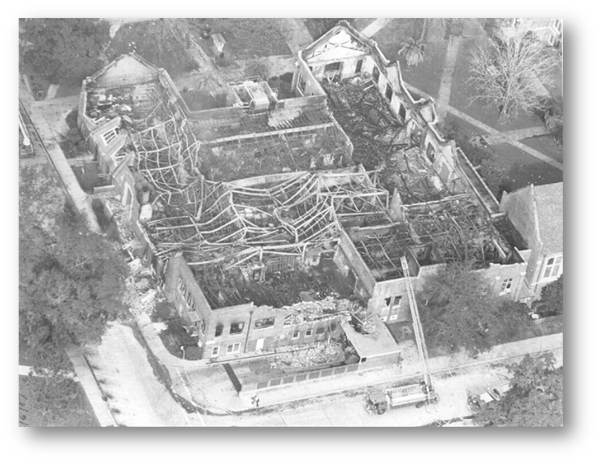

Record of Changes
Date | Summary of Changes | Page/Section | Completed By
3/11/2022  Example | The following changes occurred within the 2022 COOP: (a) added Record of Changes page; (b) Staff changes; (c) drive away kits, personal Go kit link, telework option; (d) Fl. St. update | (a)Page 2; (b)Entire document; (c)Page 4/6, (d)Page 13 documentation | P. Sparks

I. Introduction
A. Department COOP Objective

{Department Name and Description}
COOP (Continuity of Operations) is an effort within individual University of West Florida units to facilitate the continued provision or restoration of mission essential functions during a wide range of potential emergencies.

B. Purpose and Scope

This document is intended to assist and guide preparation for and response to a COOP activation. The Annex outlines the essential functions, positions, equipment, records, and other resources needed to implement this plan. Organization, relocation, delegation authority, and operation during a COOP activation are also described.

The COOP plan provides a framework for sustaining essential operations for up to 30 days. During this period, it is expected that {Department Name} will coordinate with the University administration to determine long-term arrangements necessary to restore complete operations. Its goals include responding or reacting to an event or emergency, restoring critical time-sensitive operations, and eventually recovering to full functional capacity, which is encompassed in the plan.

C. Situation and Assumptions

- Emergencies can cause disruptions to operations, damage to facilities, and impact employees.
- Emergencies, or potential emergencies, may affect the ability of EH&S to perform mission essential functions from its primary location.

D. Authorities and References

Florida Statutes, the Florida Board of Governors, mandate each state university to have a COOP. Additionally, the University of West Florida mandates departments to have a COOP. This guidance document applies to the {Department Name} to fulfill UWF’s COOP responsibilities.

State of Florida
- Florida Statutes Chapter 252.365
- Continuity of Operations Implementation Guidance, Florida Division of Emergency Management
- Continuity of Operations Preparedness Publications, Florida Division of Emergency Management

University of West Florida
- UWF/Reg 5.020 - Trespass and Access to University Property
- ES-06, Emergency Management, as it may be amended
- ES-05, University Risk Management and Insurance, as it may be amended
- P-04, Authority to Sign Contracts, as it may be amended
- P-09, Emergency Closure, as it may be amended

Board of Governors
- Board of Governors Regulation 3.001 Campus Emergency Management,

Federal
- Continuity Guidance Circular February 2018, Federal Emergency Management Agency

UWF Authorities: {Department Name}
- {Depatment – Chair/Director/Dean}

II. Mission Essential Functions
Mission essential functions are those which must be continued to provide vital services, maintain the safety of University students, faculty, staff, and visitors, and sustain University operations. Functions not deemed mission essential can be deferred until additional personnel and resources become available.

Mission essential functions should be restored on a priority basis. Functions that need to be restored within one day are Priority 1s. Functions that can be restored later than one day but within seven days are Priority 2s. Finally, functions that can be restored later than seven days but before thirty days are Priority 3s.

The table below provides an overview of {Department} essential functions and associated priority levels.

Essential Function | Priority | Restoration Timeframe
Ensure people and property are safe. | 1 | 1 Day
Alert State/Federal agencies as needed. | 1 | 1 Day
Implement a communications protocol to external constituents (media, staff, and students) | 1 | 1 Day
 | 2 | 2-7 Days
 | 3 | 8-30 Days

III. Essential Resources
Essential resources are those needed to support the department’s ability to complete its essential functions. {Department} key resources are summarized in the sections below.

- Essential Personnel
The following personnel, listed by position, will support a COOP activation by implementing this plan and completing the action necessary to maintain or restore essential functions.

Essential Positions | COOP Role and Responsibility
Director | {Describe Role and Responsibility}
Assistant Director | {Describe Role and Responsibility}
Coordinator | {Describe Role and Responsibility}

- Identification and Protection of Vital Records and Databases

The following vital records and databases, including both physical and electronic, are necessary to maintain or restore designated essential functions. All vital records and databases are accessible through the locations indicated below. A method is needed to allow access, either remotely or through relocation, to the alternate site as detailed in Section IV.

Vital Record/Database | Location(s) | Type | Information Function
Vital records | {Location} | Hard copy and digital | {List information function}
Shared Departmental Drives | UWF Server | Electronic | Essential working files

- Essential Systems and Programs

The following communications systems, IT hardware, and software are necessary to maintain or restore designated essential functions. Access to these systems is needed to allow access, either remotely or through relocation, at the alternate site as detailed in Section IV.

According to the UWF IT Security policy contained in the (Information Technology Continuance of Operations Plan (ITCOP)), critical IT resources must be preserved against loss or corruption by appropriate backup procedures.

Hardware/Software Type | Location | Description/Use
Gmail | Network | Communication to campus
Google Docs | Network | Create and retrieve documentation that will keep the restoration of the campus on track; keep the Vice President, F&A and Police informed; and provide a sense of normalcy.
Computers, Laptops, Tablets, and Monitors | {List current location} | {List description and use}  This hardware permits employees to work remotely (access to essential files, communication, etc.) necessary for EHS records and processing.
Operating systems, Microsoft Office, Adobe, Google, | {List current location} | Spreadsheets, word processing, communications, graphics

IV. Alternate Site
An emergency may leave {Department’s} current location inaccessible or inoperable, necessitating the relocation of some employees to an alternate site to maintain or restore essential functions. The table below outlines the resources necessary to function from an alternate site.

Alternate Work Site Key Elements | Alternate Work Site Requirements
Number of Employees | {List number of employees}
Drive-away kits | Office supplies, badges, PCards, maps, radios, chargers, laptop computers, etc.
Personal Go-kits and Family Disaster Planning | http://floridadisaster.org/
Equipment | Laptop/tablet, chargers
 | Department Vehicles
Vital Records & Databases | Internet/network access needed for access to the cloud (e.g., Google Drive), emails, and {Department} Google drive
How will needed Vital Records, Databases, and Equipment be Transferred or Accessed: | From Cloud (Amazon cloud storage) Some files may be accessed via Google Drive or UWF server.

The table below outlines items, including equipment, IT hardware, records, and databases, which need to be relocated to the alternate site.

Item | Notes
Computer and monitor | Each employee has a laptop and tablet that can be carried with them to an alternate location.
Laptops | This includes the laptops, peripherals, and charging cables.
Printers | This includes individual printers as well as larger network printers. Department could operate with one or two of our networked printers.
Other items | This may include a variety of hard copy files, binders, office supplies, etc.
Internet and Network Access | Vital for accessing emails, shared network drives, and other systems such as Banner, Concur, etc.

An alternate facility may be identified from existing {Department} infrastructures or external sources such as another department. The facility selected should have sufficient space and equipment to maintain designated employees and be capable of sustaining operations for up to 30 days.

The following alternate location has been identified according to the criteria listed above. [For locations controlled by another department, attach a letter of agreement authorizing use of the facility during COOP activations.]

Alternate work site | Location
{Identify alternate work site} | {Identify location}
Telework/remote worksite | Each employee may work from home or an alternate location with sustainable power and internet

V. Interrelationships
Maintaining or restoring essential functions during a COOP activation will require coordination with other UWF departments. The following table indicates other departments with which {Department} must coordinate to continue each essential function. Identified departments should be notified if the COOP plan is activated.

Essential Function | Priority Level | Vice President, F&A | Facilities & Utilities | Building Services | EH&S | Police | President Office | Provost | Department 8 | Department 9 | Department 10 | Department 11 | Department 12
Obtain information relevant to the incident that activated the COOP Plan. Facilitate making decisions regarding campus operations | 1 | X | X | X | X | X
Determining the academic impact of this incident. | 2 | X |  |  |  |  | X | X

VI. Delegation of Authority and Lines of Succession
If the [VP/DDD] is out of contact or delegates authority, the following list will be employed for the succession of leadership. Cessation of the delegation will occur when the [VP/DDD] is in contact and can assume duties.

The succession of [VP/DDD] by Position
1 | Dean/Director/Chair
2 | VP Divisional/Provost

Personnel other than [Fiance and Controller] do not have financial authority.

VII. Employee Notification and Accountability
Notification of essential personnel during a COOP activation will take place as follows:

 | Employee Notification Procedures
1 | Notice to Director
2 | The Director will notify departmental Staff via text, email, or phone.

VIII. Tests, Training, and Exercises
An exercise of the COOP plan should be conducted by {Department} on an annual basis, the exercise should include a test of the identified alternate facility to assess the accessibility of equipment, IT resources, databases, and records. Needed updates and areas for improvement revealed during the exercise will be evaluated and included in the plan as appropriate.

A part of the exercise process will include training of positions tasked within this document as well as {Department} leadership on the COOP plan. Awareness meetings on the COOP plan will be conducted on an annual basis with all employees.

IX. Implementation of COOP Plan
Following an incident that impacts {Department}, the {DDD} will determine the effects on the organization’s facilities and operations. Based on the evaluation, the {DDD} will implement all or portions of the COOP plan as necessary to maintain or restore mission essential functions.

This document serves as a guideline for the implementation of the COOP plan. See below for the complete plan.

X. Essential Functions Tables
The following pages include {Department’s} Essential Function tables. These tables summarize the information included in Annex Sections II-IV and can serve as a quick reference for staff working to continue each essential function during an incident.

Priority 1 – {Insert Essential Function Name}
Department XXXX
Essential Function | Priority | Steps to complete Essential Function
Request additional funding to support emergency | 1 | Inform VP, Finance & Administration of the monetary requirement to restore UWF functions.
Required Personnel (minimum number required)
Positions | # of Personnel Required | Skills Required
Director or Assistant Director | 1 | Management, communication, and working knowledge of COOP
Alternate Continuity Staffing or Strategy
List strategies and implementation steps for alternative staffing to complete the essential function (substitutes, multi-tasking, volunteers, mutual aid, contractors, shift extension, telecommuting, reduced service, other).
Alternate strategy |  | Implementation steps
{Identify alternate strategy} |  | {Describe implementation of steps}
Infrastructure needs
List any infrastructure needs to complete the essential function (IT, utilities, space, etc.).
Infrastructure need description
{Identify infrastructure needs}
Vital Records
List any records and information that are required to complete responsibilities and tasks associated with this essential function.
Record Description |  | Location
{Identify record description } |  | {Describe location}
Emergency contact information for Division Senior Leaders and Cabinet |  | Contact List

Priority 1 – {Insert Essential Function Name}
Department XXXX
Essential Function | Priority | Steps to complete Essential Function
Secure people and property | High | - Evacuate/secure emergency location  - Inform Emergency Manager and Division Vice President  - Inform State/Federal agencies  - Begin assessment  - Perform cleanup
Required Personnel (minimum number required)
Positions | # of Personnel Required | Skills Required
{Identify Positions} | {insert # of personnel required} | {Identify skills required}
Alternate Continuity Staffing or Strategy
List strategies and implementation steps for alternative staffing to complete the essential function (substitutes, multi-tasking, volunteers, mutual aid, contractors, shift extension, telecommuting, reduced service, other).
Alternate strategy |  | Implementation steps
{Identify alternate strategy} |  | {Describe implementation of steps}
Infrastructure needs
List any infrastructure needs to complete the essential function (IT, utilities, space, etc.).
Infrastructure need description
Based on an emergency can vary from each event. (phone, computers, video equipment, drones, internet, and network access)
Vital Records
List any records and information that are required to complete responsibilities and tasks associated with this essential function.
Record Description |  | Location
{List record description} |  | {Identify location}
Contact information for government officials, University personnel, regulatory bodies, accrediting agencies, FLBOG staff, and external partners |  | Google Mail  Google Drive

Priority 3 – (Insert Essential Function Name)
Department XXXX
Essential Function | Priority | Steps to complete Essential Function
{Identify essential function} |  | - Insert Step  - Insert Step
Required Personnel (minimum number required)
Positions | # of Personnel Required | Skills Required
{Identify Positions} | {insert # of personnel required} | {Identify skills required}
Alternate Continuity Staffing or Strategy
List strategies and implementation steps for alternative staffing to complete the essential function (substitutes, multi-tasking, volunteers, mutual aid, contractors, shift extension, telecommuting, reduced service, other).
Alternate strategy |  | Implementation steps
{Identify alternate strategy} |  | {Describe implementation of steps}
Infrastructure needs
List any infrastructure needs to complete the essential function (IT, utilities, space, etc.).
Infrastructure need description
Based on an emergency can vary from each event. (phone, computers, video equipment, drones, internet, and network access)
Vital Records
List any records and information that are required to complete responsibilities and tasks associated with this essential function.
Record Description |  | Location
{List record description} |  | {Identify location}

