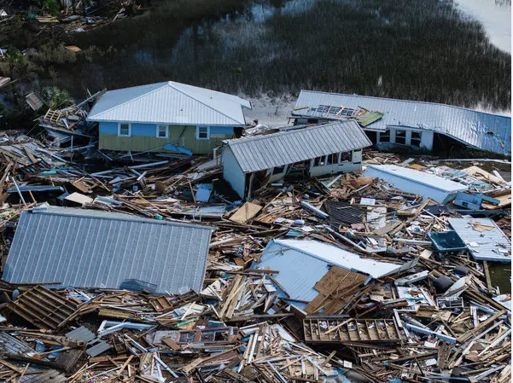
Last Reviewed:
Version Date:
Continuity of Operations Plan (COOP)
Your Department/College Name Here

Plan Approval

Department:

Division:

Prepared By:

Reviewed By:

Approved By (Dean/Director/Vice President):

Date:

Next Annual Review Date:

This document contains continuity planning information intended for University personnel. Distribution should be limited to individuals with a business need to know. Copies maintained electronically shall be stored on approved University systems.

Record of Changes
Date | Summary of Changes | Page/Section | Completed By

Acronym List:

COOP – Continuity of Operations Plan

MEF – Mission Essential Functions

PPE – Personal Protective Equipment

I. General Overview of the Plan

A. Continuity of Operations Planning

Continuity of Operations (COOP) is an effort within the University of West Florida departments to ensure the continued performance of essential functions during a wide range of potential emergencies. This is accomplished through plan development, comprehensive procedures, provisions for alternate sites, personnel, resources, interoperable communications, and vital records/databases.

B. Situations and Assumptions

This plan is predicated on a realistic approach to the problems likely to be encountered during a major emergency or disaster. The following assumptions are made and should be used as a general guideline in such an event.
- An emergency or disaster may occur at any time of the day or night, weekday, weekend, or holiday, with little or no warning.
- Emergencies or disasters may be community-wide. It may be necessary for the department to plan for and carry out disaster response and short-term recovery operations in conjunction with other campuses, agencies, or local resources.
- The succession of events in an emergency or disaster is not predictable. This plan should serve only as a guide and checklist. It may require modifications to meet the requirements of the emergency.

C. Purpose

The purpose of this plan is to minimize disruption to the essential functions of this department. This plan will serve as a guide to ensure the succession of key leadership, continued performance of the essential functions, the safety of personnel, survivability of critical equipment, records, databases, and other assets, and recovery from such an event.

D. Scope

The scope of this plan includes all critical services, processes, and functions that must be continued or recovered. This plan includes the following areas:
Department Name | Building Number | Room/Office Number
Add only the locations that are under the scope of this plan

E. Objectives

The plan’s primary objectives are:
- Preserve the safety of personnel and visitors
- Assign the delegation of authority
- Provide the ability to continue essential functions
- Outline the provisions for the protection of critical equipment, records, and other assets
- Identify alternate work locations
- Outline the logistical support and resources needed to enact this plan
- Address personnel issues and coordination
- Establish a communications plan that provides for alternative means of communication
- Provide for the protection of vital records and databases
- Identify steps taken to activate this plan, enact the plan, and terminate the plan

F. Authorities and References

Federal directives, Florida statutes, and the Florida Board of Governors mandate each state university have a COOP. Additionally, The University of West Florida requires that departments considered to perform essential functions must have a COOP. The list of authorities and references below are meant to be comprehensive but are not exhaustive.

Federal

- HSPD-8 National Preparedness
- Presidential Policy Directive-40 (National Continuity Policy)
- FEMA Continuity Guidance Circular 1
- FEMA Continuity Guidance Circular 2
- Robert T. Stafford Disaster Relief and Emergency Assistance Act, PL 100-707
- Disaster Mitigation Act of 2000, PL 106-390
- Homeland Security Act of 2002, PL 107-609

State of Florida

- Florida Statutes Chapter 252.365, Emergency Coordination Officers; disaster preparedness plans
- Florida Statutes Chapter 252.385, Public Shelter Space
- Chapter 9G-6, F.A.C., Review of Local Emergency Management Plans
- Chapter 1001, Florida Statutes, K-20 Governance
- Continuity of operations Implementation Guidance, Florida Division of Emergency Management
- Continuity of Operations Preparedness Publications, Florida Division of Emergency Management

University of West Florida

- ES-05, University Risk Management and Insurance, as it may be amended
- ES-06, Emergency Management, as it may be amended
- P-04, Authority to Sign Contracts, as it may be amended
- P-09, Emergency Closure, as it may be amended
- UWF/REG 5.020, Trespass and Access to University Property, as it may be amended

Board of Governors

- Board of Governors Regulation 3.001 Campus Emergency Management

G. Mission Essential Functions

Mission essential functions are those that must be continued or restored to provide vital services, maintain the safety of University students, faculty, staff, and visitors, and sustain University operations. Functions not deemed mission essential should be deferred until additional personnel and resources become available.

The table below represents a comprehensive list of essential functions within this department, however, it may not be exhaustive. The table below lists each Mission Essential Function (MEF), the position responsible for carrying it out, its priority level, and the estimated time required to restore it. Priorities and completion times should only serve as a guideline due to the unpredictable nature of an emergency or disaster.

Essential Function | Responsible  Position | Priority Level | Time to Restoration

H. Delegations of Authority and Orders of Succession

When an emergency or disaster occurs, the President of the university, or the President’s designee, has the authority to activate or implement emergency procedures. The order of succession for department leadership is:
Title | Successor Order

I. Alternate Work Locations

During an emergency or disaster, it may be necessary to work from an alternate location. If this department cannot work from its primary location, the following alternate work locations have been identified.
Location Name | Building Number or Address | # Of Personnel That Can Be Accommodated | On Campus or Off Campus | Network Access Available?

- Essential Resources
Name of Resource | Type of Resource | # Of Resource Needed | Location

K. Personnel Issues and Coordination

Communications Plan

This department has identified the following methods of communication to be utilized in the event of an emergency.
Communication Method | Available at an Alternate Site? | Available to the Entire Department? | Primary / Backup

L. Essential Personnel

The following personnel, listed by position, will support a COOP activation by implementing this plan and completing the action necessary to maintain or restore essential functions.
Title | Area of Responsibility | Access to Campus as Essential Personnel? | Can Perform Duties Remotely?

M. Identification and Protection of Vital Records and Databases

The following vital records and databases, physical and electronic, are necessary to maintain or restore designated essential functions. All vital records and databases are accessible through the locations indicated below.

Vital Record/ Database | Storage Location | Type of Record or Database | Essential Function | Available Offline? | Recovery Priority

N. Tests, Training, and Exercises

This COOP plan will be comprehensively reviewed every three years or as departmental changes occur. This plan will be reviewed annually to ensure that specific contact information, alternate site locations, and other information that may have changed remains updated.

Personnel identified in this plan, or those who may support its implementation will receive orientation and training to this plan and their specific responsibilities. Personnel will receive additional training when any changes to the plan occur. It is recommended that employees receive annual refresher training on this plan.

This COOP plan should be exercised annually or when major changes occur to the plan itself. Exercises should include some or all of the components of the plan. Any gaps or deficiencies identified during the exercise must be immediately remediated and the plan updated accordingly.

II. Implementation of the COOP

Phase I – Readiness and Preparedness

Departments maintain a continuous state of readiness through annual plan reviews, employee training, exercises, maintenance of essential resources, and identification of alternate work locations.

Phase II – Activation and Relocation

This plan may be activated by authorized personnel following an incident that has impacted The University of West Florida, the surrounding community, or this department. This plan may be activated in whole or in part depending upon the severity and complexity of the incident.

Once the decision has been made to activate this plan, the following priority shall be used:

1. Decision to Activate the COOP
- The designated departmental leader (e.g., Director, Chair, or Dean) will determine the need to activate the COOP based on:
  - Incident severity
  - Anticipated duration of disruption
  - Safety and operational impact assessments
- Notify university leadership and, if necessary, coordinate with Emergency Management.
- Notify ITS if technology services are disrupted.

2. Notification of Essential Personnel
- Alert essential personnel via:
  - Email, text messaging, campus alert systems, or group call-out protocols
- Include:
  - Reporting instructions (location, time)
  - Transportation logistics (if applicable)
  - Expectations for operations at the alternate site

3. Activation of Alternate Work Location
- Prepare designated alternate location (on- or off-campus).
- Ensure availability of:
  - Power and internet connectivity
  - Communication equipment (e.g., phones, radios)
  - Workstations, storage, and access to necessary records or systems

4. Relocation of Equipment and Resources
- Relocate or access essential items, including:
  - Laptops, printers, phones, and other IT equipment
  - Portable communication devices
  - Critical documentation (e.g., SOPs, vital records)
  - Emergency supplies and personal protective equipment
- Coordinate transportation for personnel and equipment, as needed.

5. Continuity of Essential Functions
- Prioritize continuation of mission-critical functions such as:
  - Life safety services
  - Public information or communication duties
  - IT services or academic support
- Implement manual processes (e.g., paper logs) if digital systems are unavailable.

6. Establish Communication Protocols
- Utilize redundant communication systems (e.g., radios, mobile networks).
- Coordinate with:
  - University IT for secure system access
  - Emergency Management for operational updates and resource coordination
- Ensure communication between:
  - Field personnel or staff
  - University leadership
  - External partners or agencies

7. Documentation and Status Reporting
- Begin recording:
  - Incident response activities
  - Personnel assignments and staffing levels
  - Equipment use and functionality
- Maintain daily logs to support transparency and recovery documentation.

8. Security and Access Control
- Secure both primary and alternate facilities, including:
  - Sensitive records
  - Specialized equipment
  - Entry points and restricted areas
- Assign personnel to monitor and enforce security protocols.

9. Support for Employees
- Communicate guidance regarding:
  - Pay, timekeeping, and leave policies
  - Lodging, transportation, and meal arrangements (if relocation is prolonged)
  - Mental health and wellness resources

General Decision Process Flowchart for COOP Activation
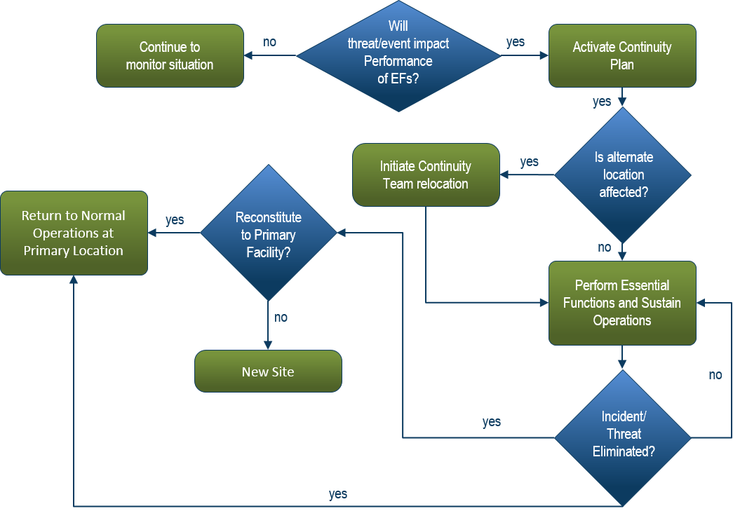

Phase III – Continuity Operations

Full execution of essential operations at alternate operating facilities is commenced.

Phase IV – Reconstitution

This plan accounts for the orderly and timely return to normal operations. Below is a list of actions to take that will efficiently terminate alternate operations and return to normal operating procedures. The severity and complexity of the incident will determine which tasks need to be completed.

1. Assessment and Authorization to Reoccupy
- Conduct a comprehensive assessment of the primary facility in collaboration with Facilities Management or appropriate departments.
- Verify the functionality of:
  - Life safety systems (e.g., fire alarms, access controls, surveillance)
  - Building infrastructure (e.g., HVAC, power, water)
- Obtain reentry authorization from university leadership and Emergency Management.

2. Relocation of Operations and Resources
- Coordinate the physical relocation of:
  - IT equipment and communication systems
  - Essential documents, files, and records
  - Office supplies and specialized tools
- Reinstall or reconnect necessary systems, including internet, telephony, and software platforms.

3. Personnel Reintegration
- Communicate return-to-work procedures to all employees.
- Resume standard work schedules, office assignments, and reporting structures.
- Provide support resources, including:
  - Mental health and wellness services
  - Debriefing sessions for affected personnel

4. Restoration of Essential Services
- Ensure resumption of all core departmental functions, such as:
  - Instructional support
  - Administrative processing
  - Student or faculty services
- Test the functionality of communication systems (e.g., mass notifications, phones, email).

5. Transfer of Records and Data Integrity
- Validate the integrity of data collected during continuity operations.
- Migrate offline or temporary documentation into permanent systems.
- Archive incident-specific records according to university retention policies.

6. Stakeholder Notification
- Inform key stakeholders, including:
  - University administration
  - External partners or vendors
  - Department staff and faculty
  - Students, if relevant to the division
- Provide operational status updates and contact information for resumed services.

7. After-Action Review & Lessons Learned
- Conduct an After-Action Review (AAR) with department leadership and Emergency Management.
- Identify:
  - Successful practices
  - Gaps in the response
  - Areas for improvement
- Document findings and submit a summary report to appropriate university entities.

8. Plan Updates and Staff Training
- Update the COOP based on findings from the AAR and reconstitution experience.
- Revise relevant protocols, resources, and contact information.
- Provide refresher training or briefings to staff on any changes made to the COOP.

