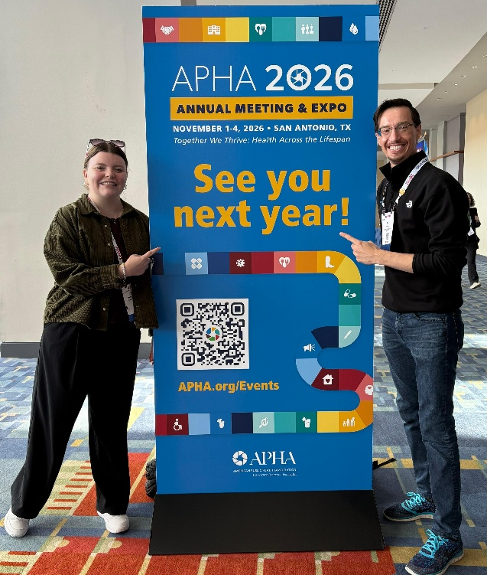
Learn What Public Health Research Looks Like in Practice
Our public health faculty are actively contributing to research across community and global health, environmental health, epidemiology, and public health informatics. Students are encouraged to explore faculty scholarship to learn about current projects, discover opportunities for collaboration, and gain inspiration for internships, capstones, or graduate study.
🎓 Meet Our Faculty
- Dr. Colette Davis
- Dr. Robert "Wes" Farr
- Dr. Daudet Ilunga Tshiswaka
- Dr. Emmanuel Keku
- Dr. Justice Mbizo
- Dr. Melanie A. Sutton
- Dr. Karishma Chhabria Unrue

Take the next step:
Pick a faculty member → Search their name → Start exploring.
Want to explore their full portfolio of work to learn about methods, data sources, and research themes across public health? Read the studies, reports, conference papers, and collaborative projects our faculty have published by exploring their work on the widely used research platforms noted below. These platforms provide up-to-date lists of articles, presentations, and impact metrics.
🔍 Google Scholar: https://scholar.google.com
Search by entering: First Name Last Name + “public health”
Example: “Faculty Name public health”
Google Scholar is the easiest place to see their publications, citation trends, co-authors (including students!), and links to full-text articles when available.
🟩 ORCID iD: https://orcid.org
Many faculty maintain ORCID profiles. Search their name to find verified publication lists, datasets, conference proceedings, and grant-related outputs.
🧪 ResearchGate or Academia.edu: https://www.researchgate.net or https://www.academia.edu
Some faculty share work on academic networking sites. Search by their full name to see working papers, posters and conference abstracts, preprints and data visualizations, and Q&A threads tied to their research area.

🌱 Take the Leap—Your Future Career Will Thank You
Find a topic that makes you think? A study that sparks your interest? Reach out to that faculty member—this is how meaningful opportunities begin. Many of our faculty offer openings for motivated students to join their research teams, contribute to publications, assist with data or community projects, and build real professional experience.
Engaging with faculty research helps:
- students stand out in internships, graduate school applications, and early career jobs by gaining hands-on experience that builds confidence and professional skills
- parents see their students thrive, gaining skills that translate directly to employment
- community organizations connect with students who care about local health issues and solutions
- employers identify graduates who have already worked on real problems with real outcomes
UWF Public Health is where learning becomes leadership. This is more than reading research—it's your chance to participate in it with us.

