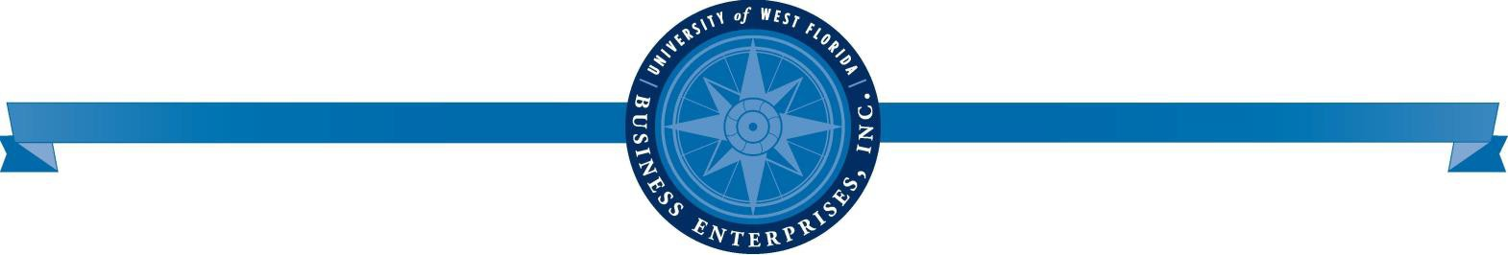

2022-2023 UWF Business Enterprises, Inc. Board of Directors Meeting Dates

- The meeting dates below were approved by the BEI Board of Directors on 4/25/22.

- Unless the Board Chair directs otherwise, BOT meetings begin at 1:00 p.m. Central Time.

- Additional meetings may be scheduled as needed and a scheduled meeting may be canceled due to circumstances and pending business items.

- The BOD meeting dates, public notices, agendas and minutes are accessible on the BEI website @ uwf.edu/bei.

- BEI-BOD meetings may be held virtually via Zoom or in person at the UWF Conference Center, UWF Main Campus, Bldg. 22 or by both virtual and in person.

SEPTEMBER 26, 2022

NOVEMBER 28, 2022

FEBRUARY 27, 2023

APRIL 24, 2023

UWF BUSINESS ENTERPRISES, I NC. 11000 University Pkwy., Bldg. 20E, Pensacola, FL 32514 p 850.474.25366

