**How to register and sign up for the Conflict of Interest Course**

Go to <http://www.citiprogram.org> and click on the "Register" button located in the blue log in box to the right of the homepage.

**Step 1:** Choose a participating institution from the search box. UWF students, faculty, and staff will type and select “University of West Florida”. After this you will agree to terms of service, affirm your affiliation and select “Continue to Create Your CITI Program Username/Password.”

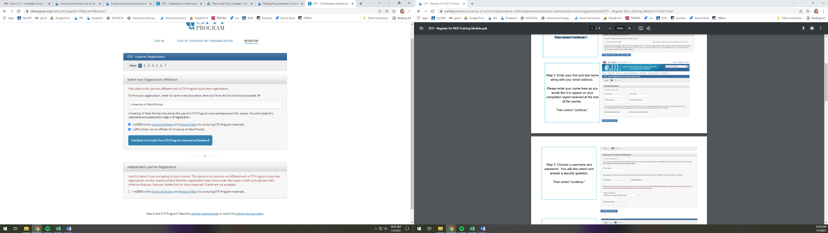

**Step 2:** Learner Registration

Input your First Name, Last Name, and Email address.

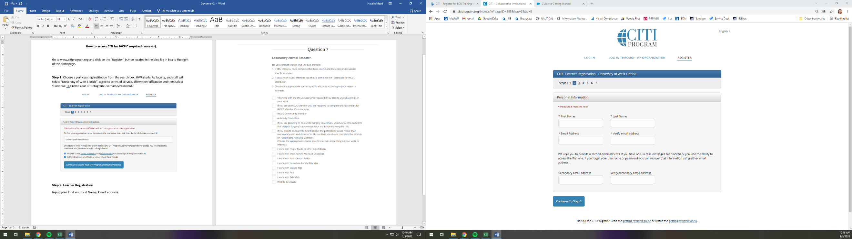

**Step 3:** Choose a username and password. You will also select and answer a security question. Then select “continue.”

**Step 4:** The CITI Program would like to collect demographic information. All information provided is voluntary. Then select “continue.”

**Step 5:** Some professionals can earn continuing education credits by completing the CITI program. Students, you should select, “No.” Then select “continue.” 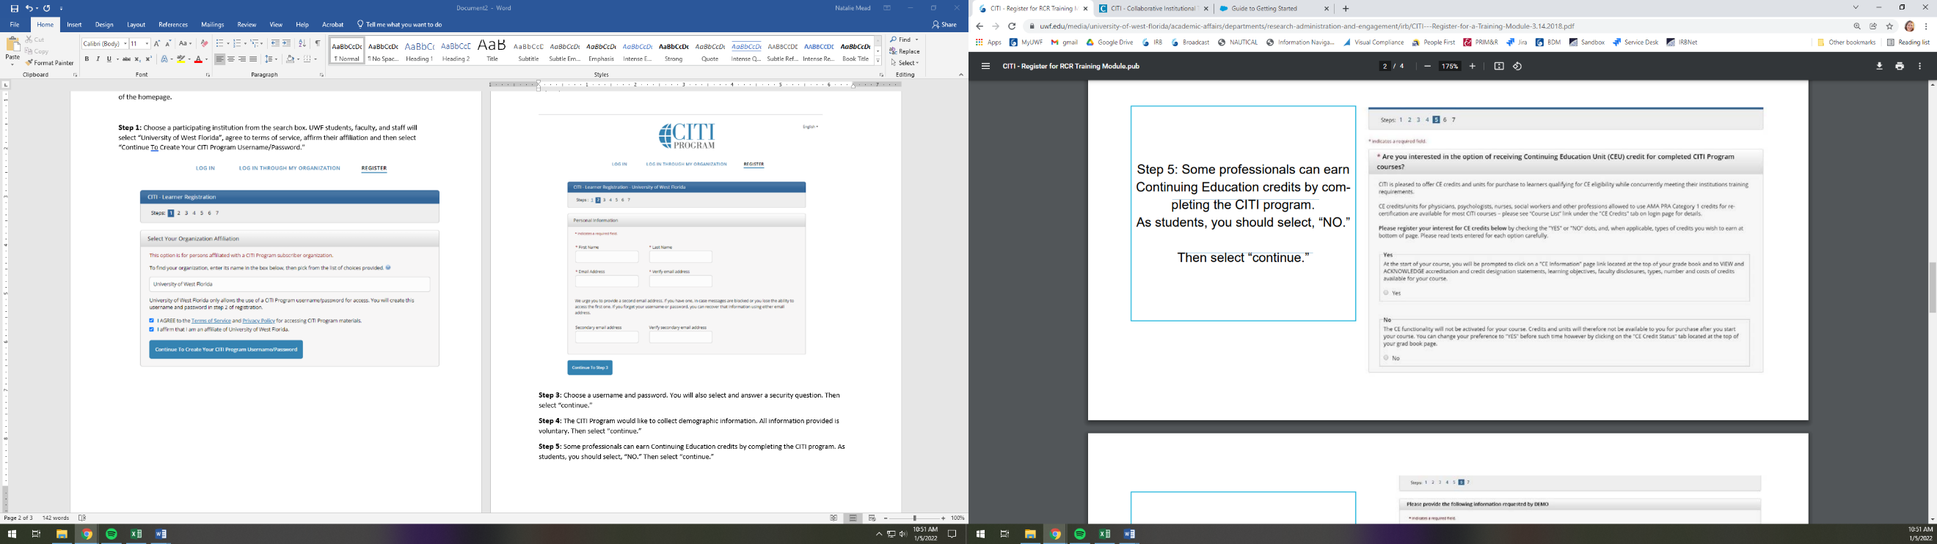

**Step 6:** Enter the required additional information. Some information requested is voluntary. Then select “continue.”

**Step** 7**: Select Curriculum**

This will provide seven questions regarding a variety of courses. Question 6 requires an answer and is for the Conflict of Interest Course. You will select, “Yes”



The UWF Research Administration & Engagement Department will be able to pull reports to verify your course completion.